ASE LAB ASSIGNMENT 9

Lab ID: 6_2

Name: Udaya Byreddy

Student ID: 16293204

Class ID: 3

Partner Name: Madhuri Sarda

Student ID: 1691679

Class ID: 21

Assignment 9:  learned about PUG template engine and how to save the details using cookies.

LOGIN PAGE using PUG Template engine

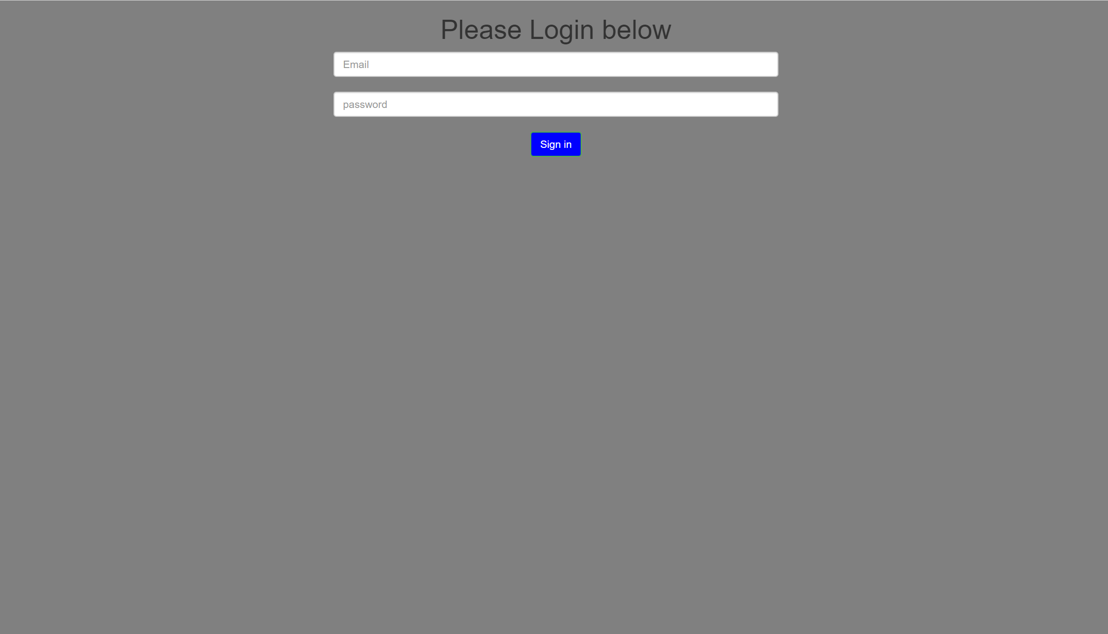

Created a new PUG-UI directory by using command: npm init. This will create package.json and package-lock.json. Once user click on Sign In button, user's email address and password will be stored in cookies and user will be redirected to details page.



Login page will generate the html in server side and send the html page to client when requested. Login page have two text boxes to enter email address and password of user.

Once user click on Sign In button, user's email address and password will be stored in cookies and user will be redirected to details page.

Installed Express : npm install express --save. Then created JS file index.js. Index.js is the entry point for APP. Installed PUG: npm install express –save.

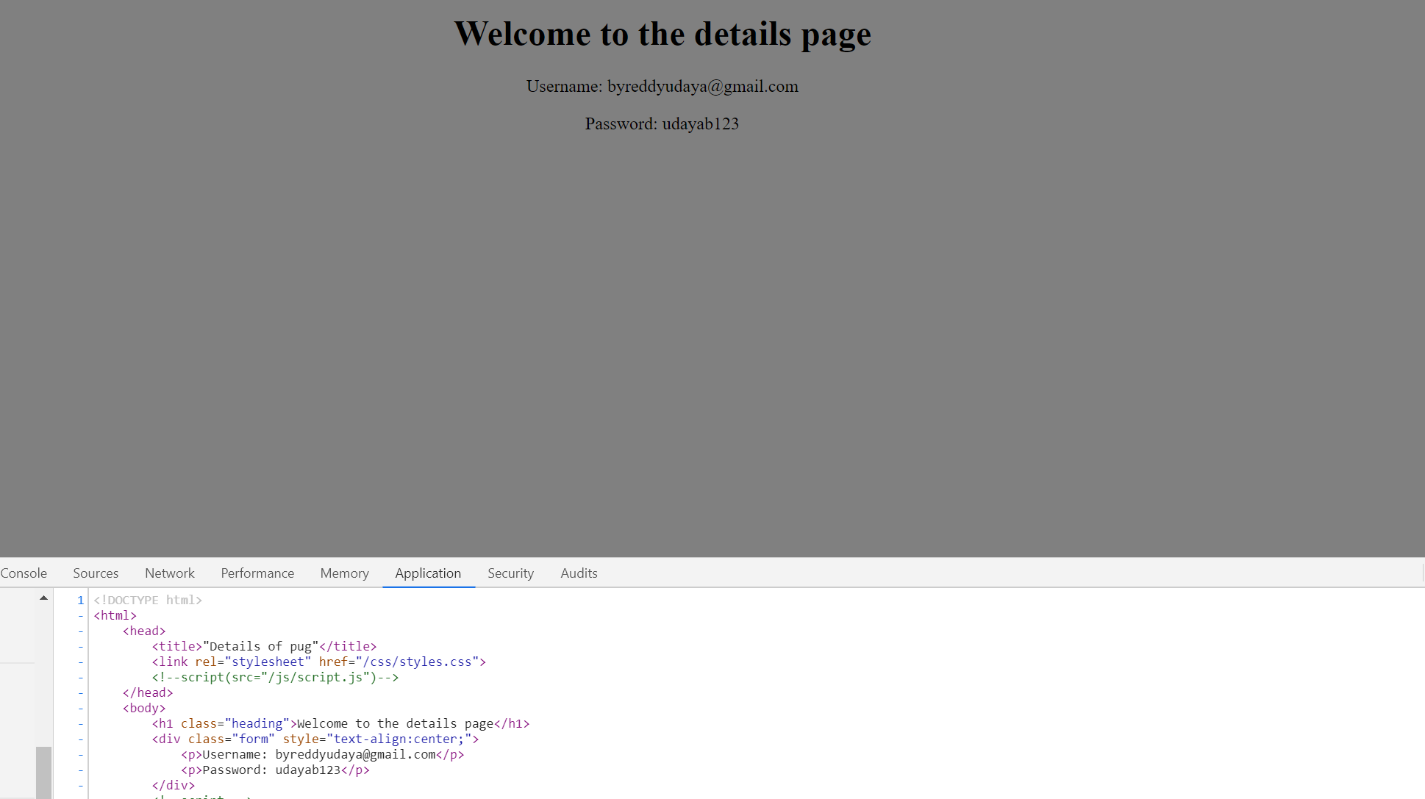

Index.js code page

index.pug file will be rendered as the default html page. This file also contains post methods to store user's details and address in cookies.

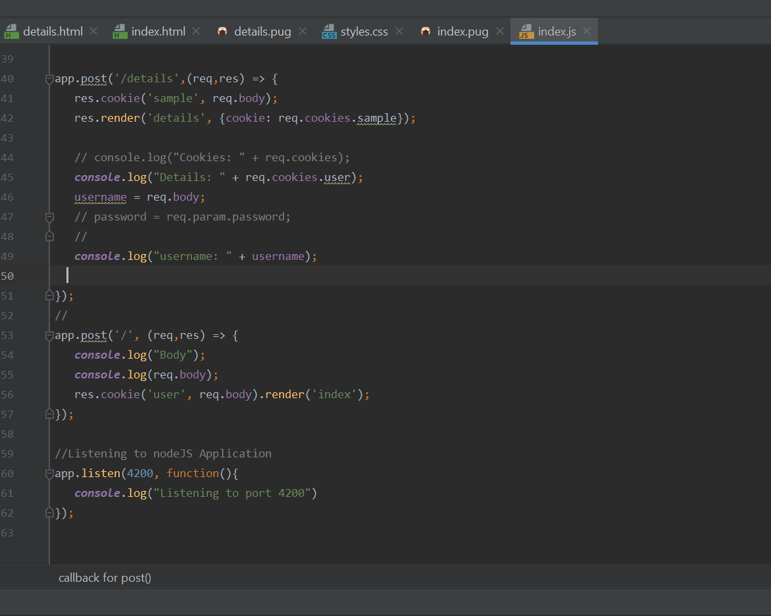

Details page code which is created using PUG template engine.

